**f. 106r**

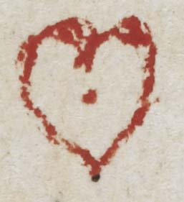

¶ca*pitulum* •89•

a tokyn of g*ra*ce

**f. 106v**

copy •

drede

no*ta* b*e*n*e* & caue

tibi ----------------------

¶

ih*esu* c*risti*

**f. 107r**

Sec*un*d*u*s liber

co*m*pany &

k i

¶ca*pitulum* p*rimum*

**f. 107v**

**f. 108r**

¶ca*pitulum* 2*m*

k ii

**f. 108v**

**f. 109r**

k iii

**f. 109v**

**f. 110r**

si de*us* p*ro* nobis q[u]i*s*

ih*esu* c*rist*

k iiii

¶

**f. 110v**

**f. 111r**

n*ota*

no*ta*

n*ota*

k v

¶ca*pitulum* •3*m*•

**f. 111v**

pacye*n*ce

¶

no*ta*

¶

h

**f. 112r**

¶ca*pitulum* •5*m*•

• Wylsnak •

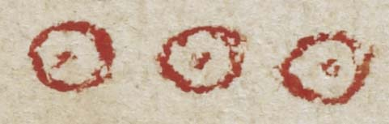

**f. 112v**

iii

¶ca*pitulum* •4*m*•

**f. 113r**

no*ta* b*e*n*e*

**f. 113v**

¶

¶ca*pitulum* •6*m*•

**f. 114r**

n*ota*

**f. 114v**

**f. 115r**

¶ca*pitulum* •7*m*•

] 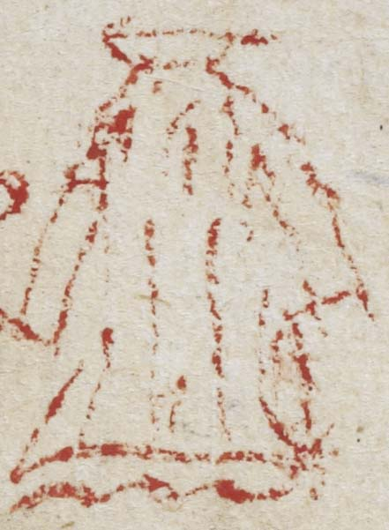

**f. 115v**

**f. 116r**

**f. 116v**

[wold]

**f. 117r**

¶ca*pitulum* •8*m*•

l i

**f. 117v**

¶ca*pitulum* •9*m*•

**f. 118r**

[l ii]

**f. 118v**

¶

**f. 119r**

¶ca*pitulum* •10•

syon]

[l ii]

**f. 119v**

no*ta* b*e*n*e* q*uod* ap*u*d deu*m*

no*n* e*st* t*ra*nsmutacio

**f. 120r**

[l iii]

**f. 120v**

¶

:•

**f. 121r**

n*ota*

 • Wyll •

**f. 121v**

¶

• or*aci*o •

**f. 122r**

n*ota*

n*ota*

pane

¶

**f. 122v**

**f. 123r**

n*ota*

ih*esu* m*er*cy q*uo*d Salthows .;.

**f. 123v**

**f. 124r**

**f. 124v**

[...]gi[s? ...]

span [...?]